ASSIGNMENT 1:

1.

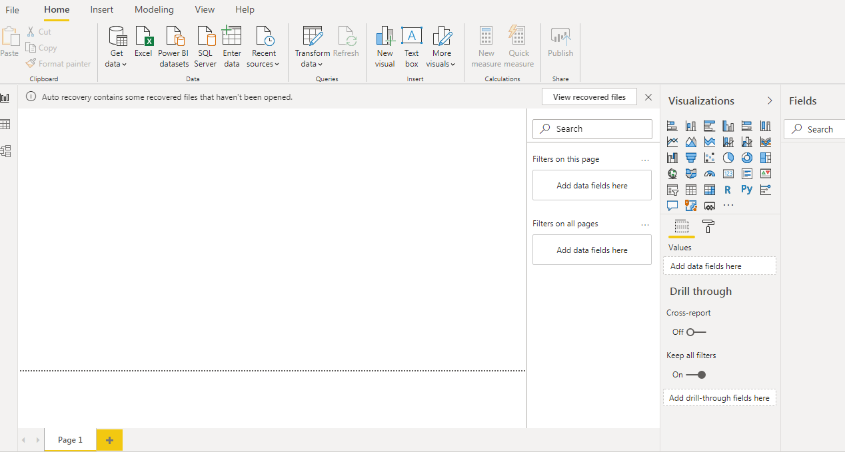

2.

___Report View:

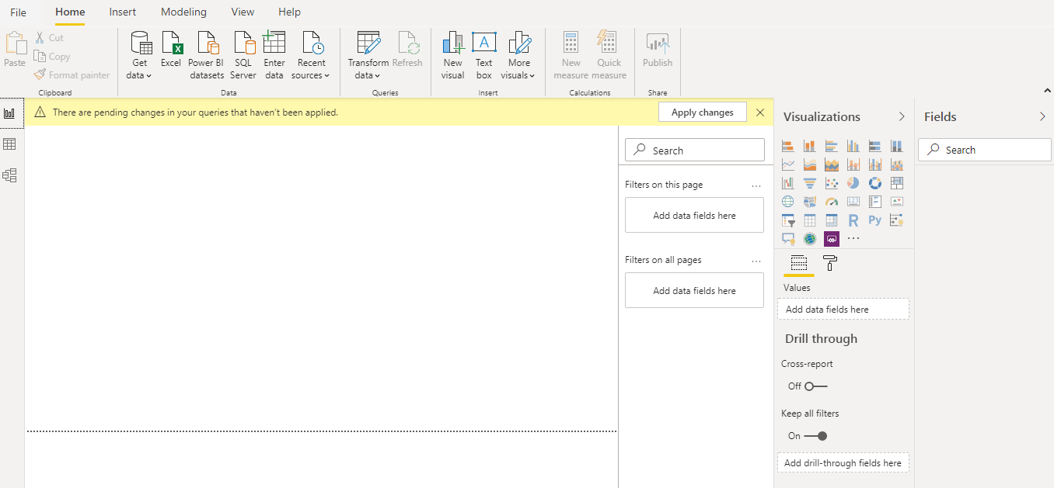

_

__Data View

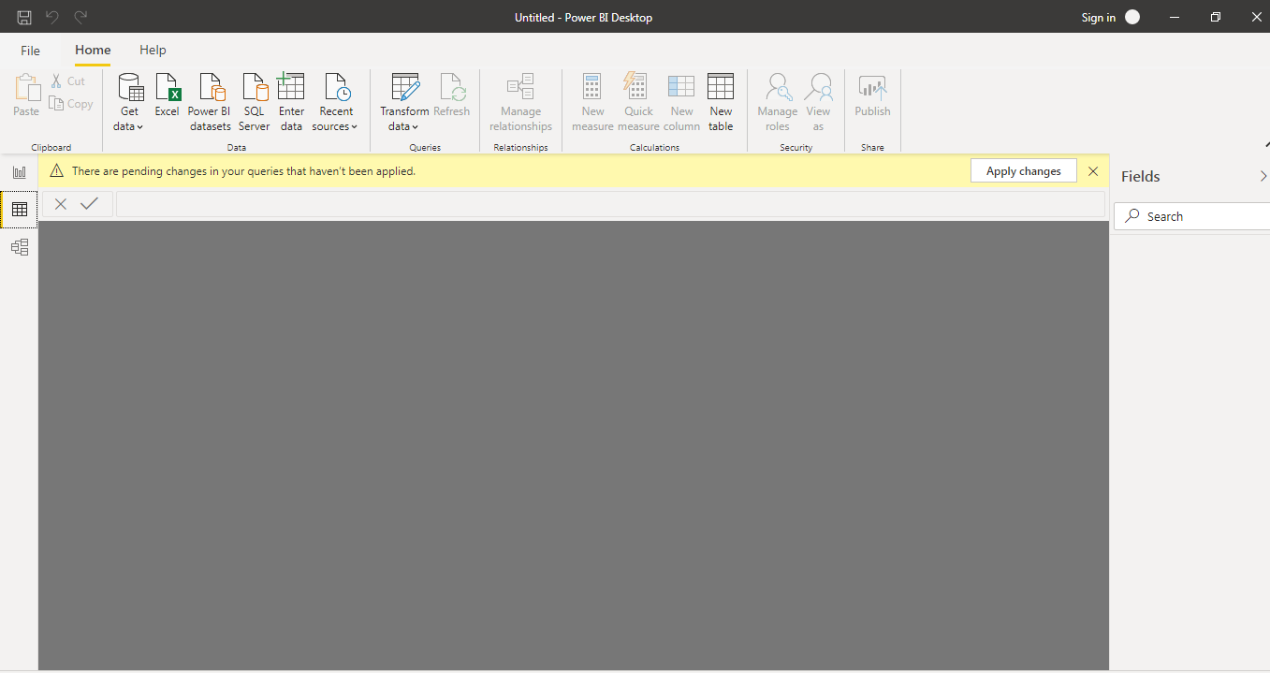

___Model View

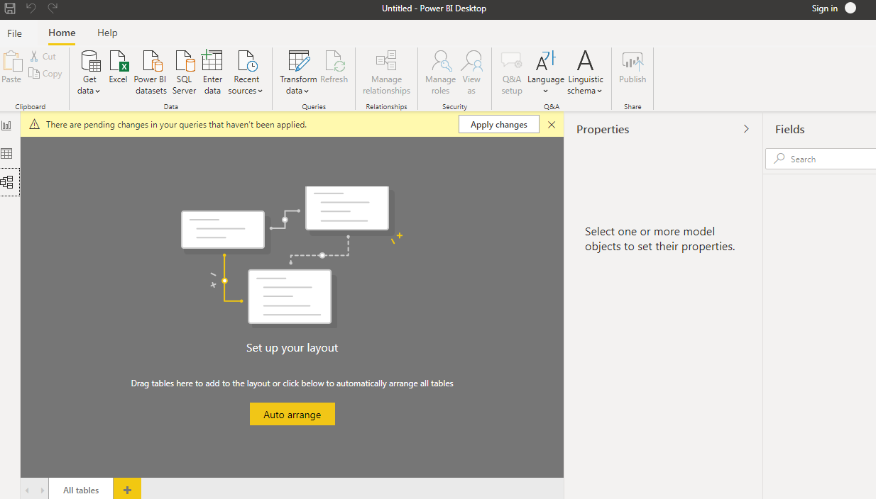

____Power Query Editor

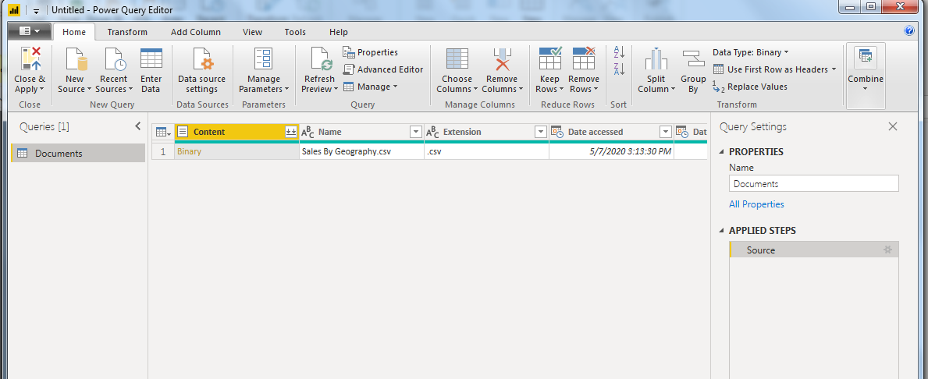

___Advanced Editor

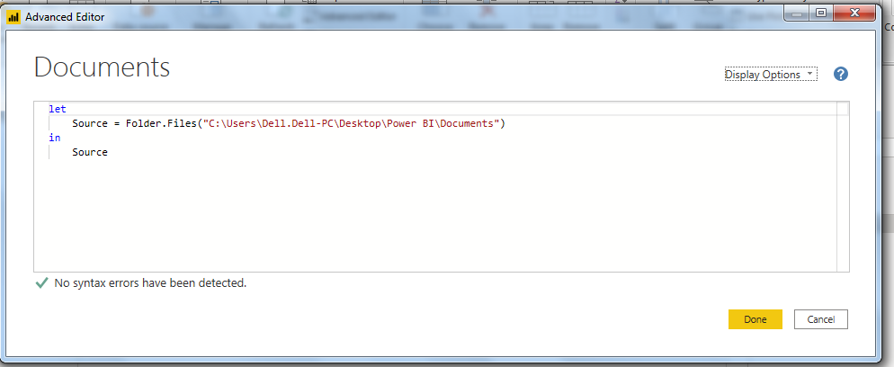

3.

____Power BI Desktop

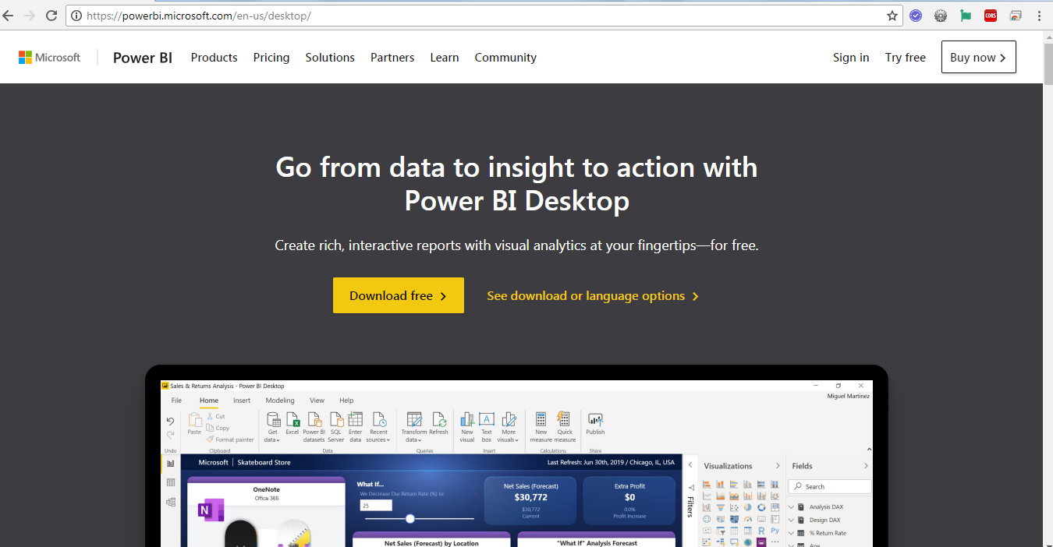  
___Power BI Pro - $9.99 Montly/User

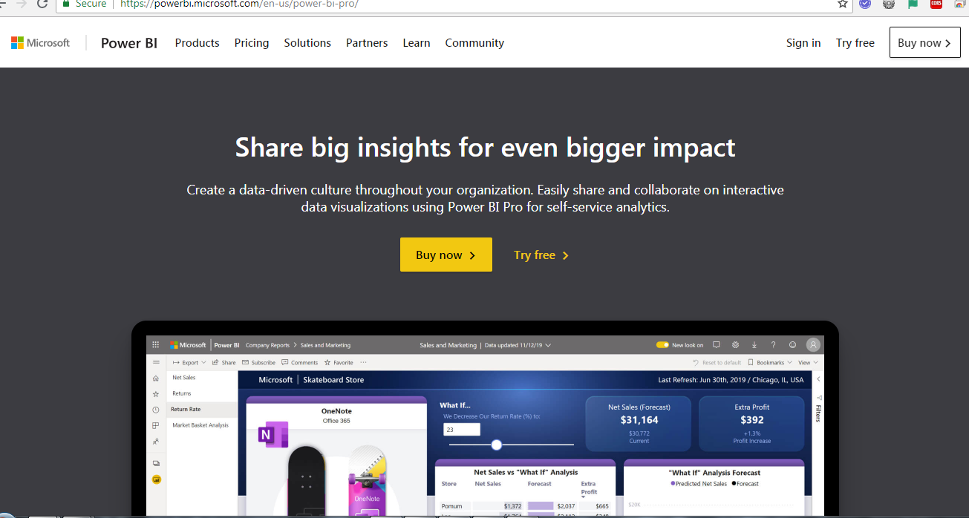

___Power BI Premium - $4,995 Montly/user

